OTIS
Administrator Guide
Using the OTIS management app: every page, every action
For OTIS administrators
As of 2 October 2026
Author: Simunye Radingwana

1. About this guide
As an OTIS administrator you look after the system as a whole. You bring cases in, allocate checks, keep people and their roles up to date, maintain the checklist, dropdown lists and email wording, and produce reports and the Trail Light export.
You do almost all of this in the OTIS management app. Checkers, advisers and T&C Managers work in the OTIS portal, which is a separate website. You can see every case there too.

How to read this guide
- Words in bold are what you see on screen: page names, buttons, fields and messages.
- Each section starts with what the page is for, then gives step-by-step instructions for each action.
- Section 17 lists common messages and what to do about them.
Good to know What you can see and do depends on the permissions set for your role in Security configuration. This guide describes a full administrator set-up. If a menu item or button described here is missing for you, your role does not include it.
In the test environments the same app is called Outcome Testing instead of OTIS. Everything else works the same way.

2. Getting around
Open the OTIS app from Power Apps and sign in with your usual work account. There is no separate password and no sign-out button inside the app; close the browser tab when you are done.
The top bar shows OTIS on the left and your name on the right. The menu runs down the left-hand side, in four groups. Click a group heading to fold it away or open it again; the app remembers your choice.
Menu group | Page | What it is for
My work | Dashboard | A summary of what is waiting, what is ageing, and how completed checks were graded
 | Case worklist | Every case, with search and filters; the way into each case
Intake | Case intake | Upload the Intelligent Office extract and deal with rows that failed
Reporting | Management reporting | Outcome volumes, remediation ageing, sign-off figures and the completed case report
 | Exports | Produce the Trail Light file, or download all data
Administration | Question library | The checklist sections and questions
 | Adviser mapping | Which T&C Manager looks after each adviser
 | Notification wording | The wording and recipients of every email OTIS sends
 | Dropdown options | The choices in the case details dropdowns
 | Security configuration | Roles, and what each role can see and do
 | People | Everyone known to OTIS, their roles and their employee codes

Messages you may see on any page
Message | What it means
No access | Your role does not include this page. The message names the permission that is missing. Another administrator can grant it in Security configuration.
Your access could not be confirmed. | OTIS could read your roles but not the permission rules, so the menu is showing built-in defaults. Your actions are still checked properly. Ask an administrator to check the permission set-up.
No access — we could not confirm who you are. | Usually your account is missing its OTIS security role. Ask the system owner to check it, then sign in again.
Page not found | The link you followed is wrong or out of date.

3. Dashboard
The Dashboard shows what is waiting, what is ageing and how completed checks were graded. Almost every figure is a link: click it to open the list of cases behind it.
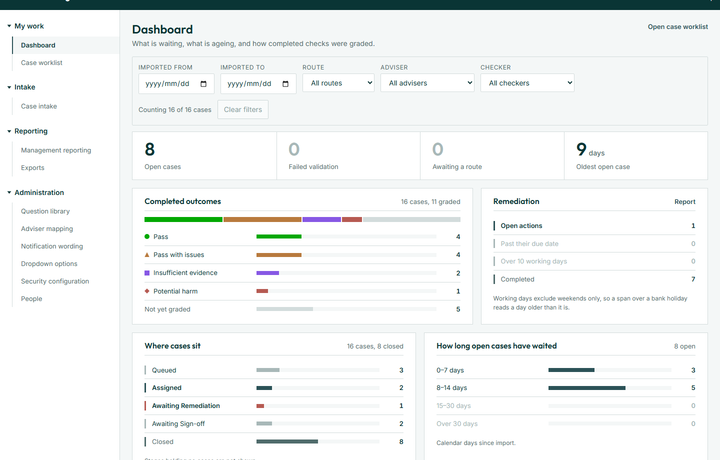
Figure 1. The Dashboard

Filtering the dashboard
Use the filter bar at the top to narrow every figure at once: Imported from, Imported to, Route (Tax only, AQS only, Tax then AQS, Not routed), Adviser and Checker. The count beside it shows how many cases are included. Click Clear filters to start again. Your filters carry through to any list you open from the dashboard.

What the dashboard shows
Panel | What it shows | Clicking it
Work in hand | Open cases, cases that failed validation, cases awaiting a route, and the oldest open case in days | Opens the matching cases in the worklist; the oldest case opens directly
Completed outcomes | How many cases are Pass, Pass with issues, Insufficient evidence, Potential harm or not yet graded | Opens the worklist filtered to that outcome
Remediation | Open actions, actions past their due date, actions over 10 working days old, and completed actions | Opens the worklist or Management reporting
Where cases sit | How many cases are at each status | Opens the worklist filtered to that status
How long open cases have waited | Open cases in bands: 0–7, 8–14, 15–30 and over 30 days since import | Not clickable

"Open" means any case that is not Closed. Working days skip weekends but not bank holidays.

4. Case worklist
The Case worklist lists every case you can see, oldest first. Click a case reference to open it.
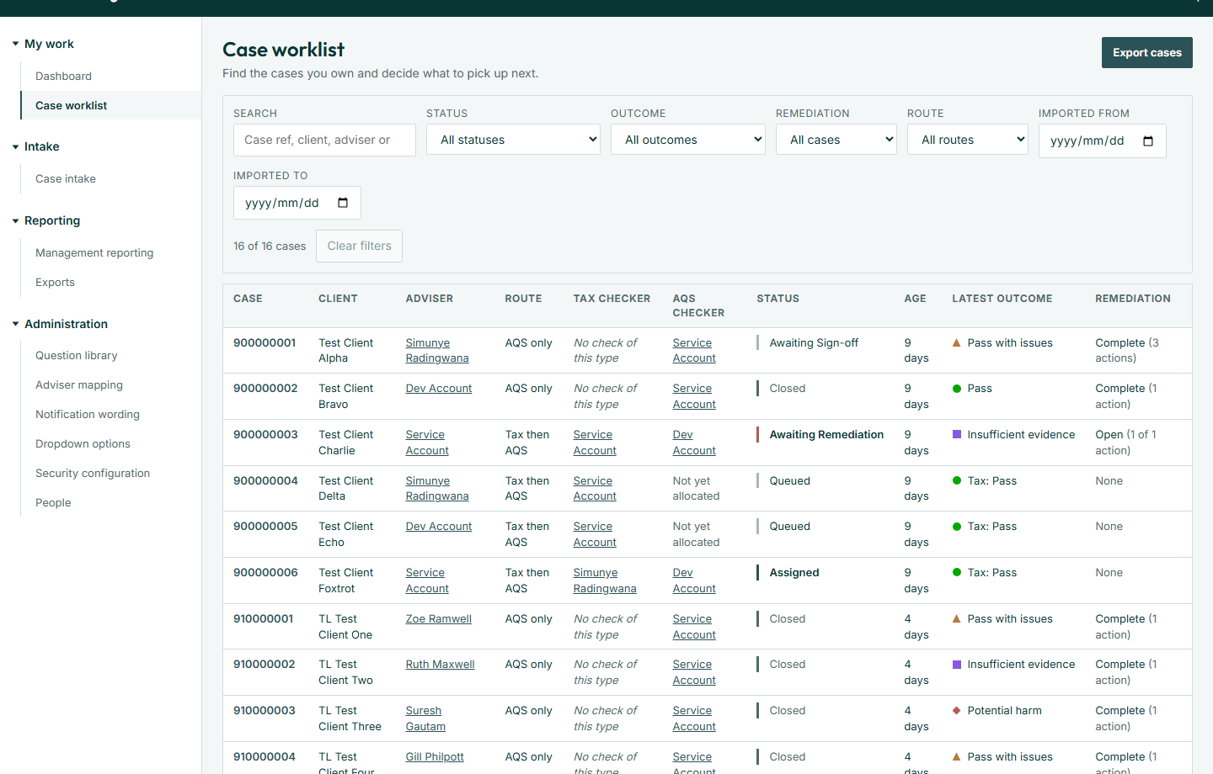
Figure 2. The Case worklist

Finding cases
- Search: type a case reference, client, adviser or the name of whoever uploaded it.
- Status, Outcome, Remediation (Open, Complete or None raised), Route and Imported from / to narrow the list. Priority appears when any case has one set.
- The count shows how many cases match. Clear filters removes them all.
- If you arrived from the dashboard or a person's page, a line such as Showing cases involving … appears. Click Show everyone to remove that filter.

Reading the list
Columns: Case, Client, Adviser, Route, Tax checker, AQS checker, Status, Age (days since import), Latest outcome and Remediation. Adviser and checker names are links to that person's cases.
- An empty checker reads Not yet allocated if the case needs that check, or No check of this type if it does not.
- A Tax-only grade shows as Tax: …. A case with no grade shows Not yet graded.
- Remediation reads None, Open (x of y actions) or Complete (n actions).

How to export the list
- Filter the list to the cases you want.
- Click Export cases.
- Choose Excel workbook (.xlsx) or Comma-separated values (.csv).
The file holds the cases currently listed, with 24 columns of case details, checkers, dates and outcomes.

5. Working with a case
Open a case from the worklist. The top strip shows its Reference, Status, Route, Uploaded by, Priority, Due date and Age. Below it are two tabs: Details and History.
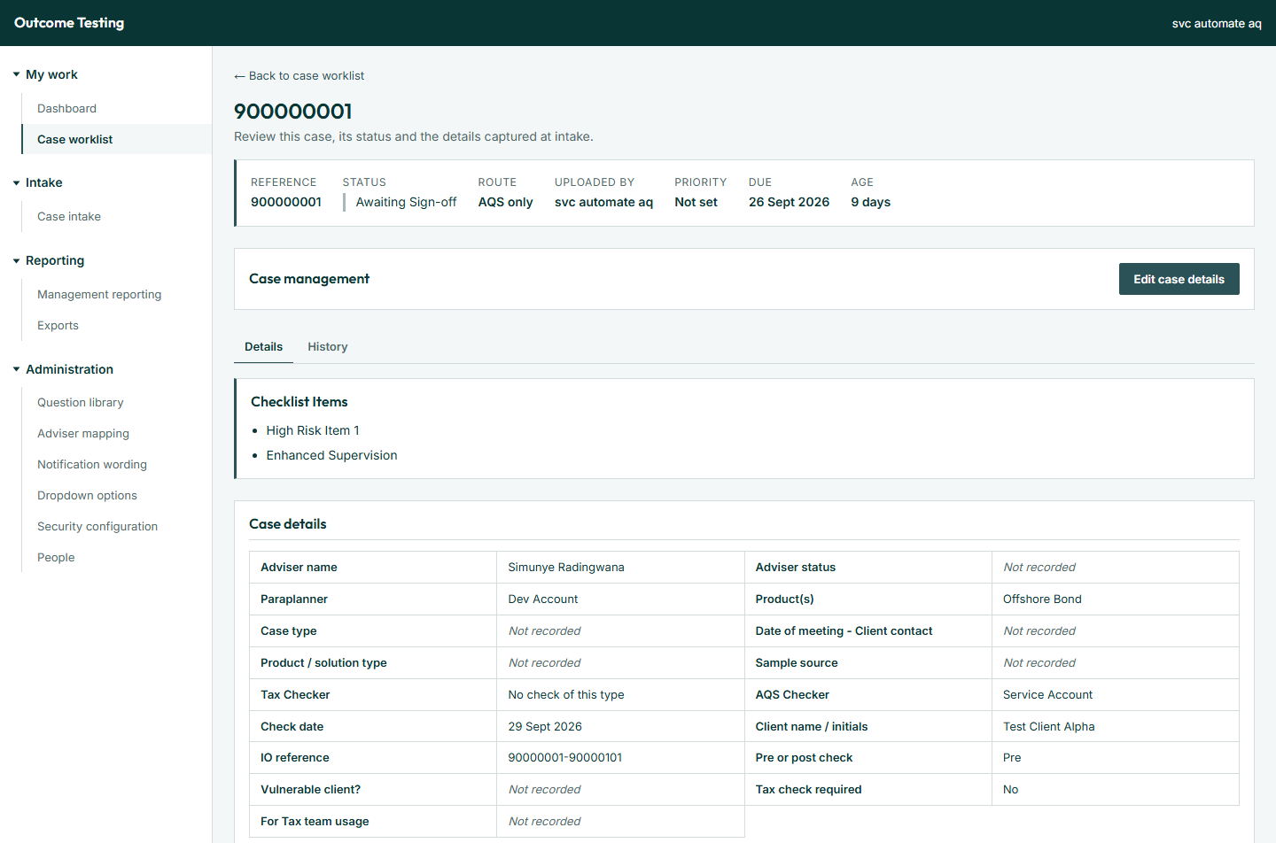
Figure 3. A case, showing the Details tab

5.1 Editing case details
Use Edit case details to correct any case information, move the case to a new status, change the due date, or allocate a check. Only the fields you change are saved, and each change is recorded in the case history.
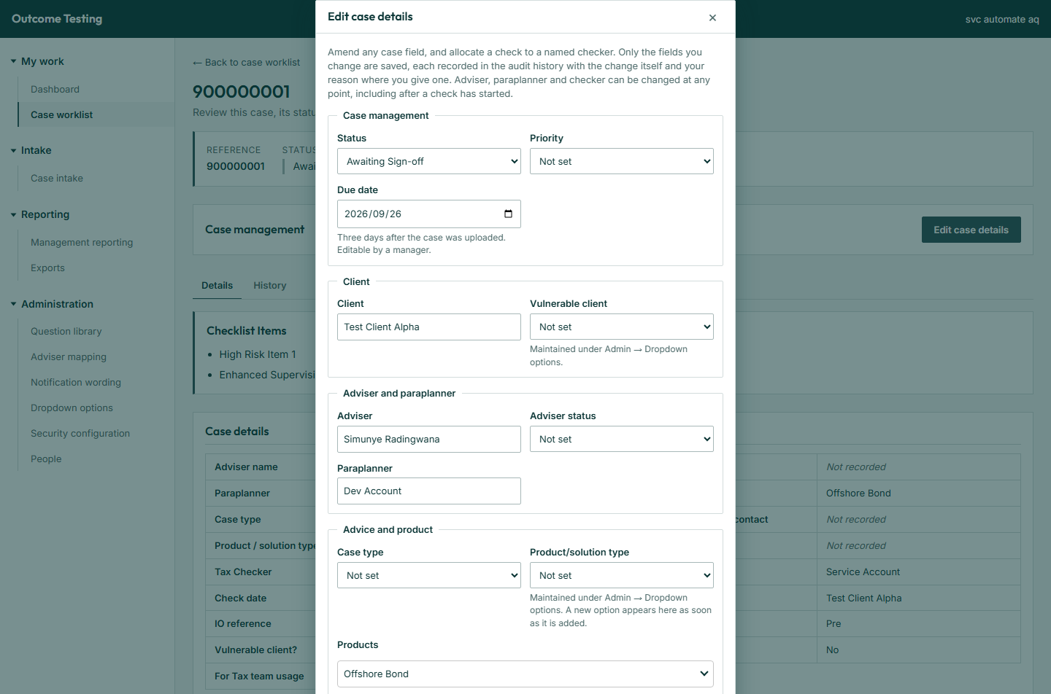
Figure 4. The Edit case details window
- Open the case and click Edit case details.
- Change the fields you need. They are grouped as Case management (status, priority, due date), Client (client, vulnerable client), Adviser and paraplanner, Advice and product, and Check and tax (tax check required, tax team disposition).
- To allocate a check, use the Checkers section (see 5.2).
- Optionally, enter a Reason explaining the change.
- Click Save changes. On success the window closes and a green message confirms what was saved, for example Case details updated.
OTIS checks your changes before saving:
- You must change at least one field or choose a checker.
- The date of meeting cannot be in the future, or later than the due date.
- The due date is set to three days after upload. Only roles with due-date rights can move it; for others it is shown read-only.
- The check date cannot be edited. It is filled in when a check is submitted.
Advisers and paraplanners You can change the adviser, paraplanner or checker at any point, including after a check has started. If a case shows Adviser not matched, correct the adviser name on the case, or the person's name on the People page, so the adviser can see it.

Changing the status
The Status list offers only the moves OTIS allows from the current status. Closed and No Check Required are final.
Current status | Can move to
Imported | Validation Failed, Ready for Allocation, No Check Required
Validation Failed | Ready for Allocation, Closed, No Check Required
Ready for Allocation | Queued, No Check Required
Queued | Assigned, No Check Required
Assigned | Review In Progress, Queued, No Check Required
Review In Progress | Submitted, Queued, Assigned, No Check Required
Submitted | Awaiting Remediation, Closed
Awaiting Remediation | Remediation In Progress
Remediation In Progress | Awaiting Sign-off
Awaiting Sign-off | Awaiting Recheck, Awaiting Remediation, Queued
Awaiting Recheck | Closed
Closed, No Check Required | Nothing (final)

5.2 Allocating or reallocating a check
Allocation is done inside Edit case details. One field appears for each check the case's route needs: Tax Checker and/or AQS Checker.
- Open the case and click Edit case details.
- In Checkers, open the Tax Checker or AQS Checker list. It starts on Leave as it is.
- Choose the person (shown as name and email). If the check has not started yet, the hint says Allocating opens this check.
- Click Save changes. The message Tax check allocated — the checker will see it in their portal worklist. (or AQS) confirms it, and the checker is emailed.
A checker field is locked, with the reason shown, when:
- the check is already submitted (Submitted [date], so it can no longer be reallocated.);
- the AQS check is waiting for the Tax check to be submitted first;
- the check belongs to the other team and only its team manager can allocate it;
- the case has no route yet. Answer Tax check required first, and the checks it needs appear.
Allocation is refused if the person is deactivated, has no OTIS role, or has no portal account. The message says which; section 17 explains the fixes. Work already done is kept when a check is reallocated.

5.3 The Details tab
- Checklist Items: what the paraplanner ticked in Intelligent Office.
- Case details: the 18 recorded case fields. Blank ones read Not recorded.
- Checks on this case: each Tax and AQS check with its status, owner and dates. Click a check to view it (see 5.6).
- Outcome: the initial and final grade of each check, and whether it was regraded.
- Who carries a fail (see 5.4).
- Remediation and sign-off →: opens the remediation view (see 5.5).

5.4 Recording who carries a fail
When a check fails, OTIS assumes by default that the paraplanner carries a File Quality fail and the adviser carries an Advice Quality fail. You can change this; it feeds the accountability columns of the Trail Light file.
- On the Details tab, find Who carries a fail. Each check outcome has its own block, marked Derived by default or Recorded.
- Tick who carries the File Quality and Advice Quality fail: the adviser, the paraplanner, or both.
- If someone else carries it, choose them under File Quality — named person or Advice Quality — named person.
- Click Record accountability. The message Accountability recorded. confirms it.
There is nothing to record on a case that passed or has no outcome yet.

5.5 Remediation and sign-off (view only)
Remediation and sign-off shows the Remediation and escalation form for the case: each fail point, the remedial action, whether the adviser performed it, its owner, target date, status, age in working days, and the sign-off decision. Below it are the sign-off answers and the regraded outcome.
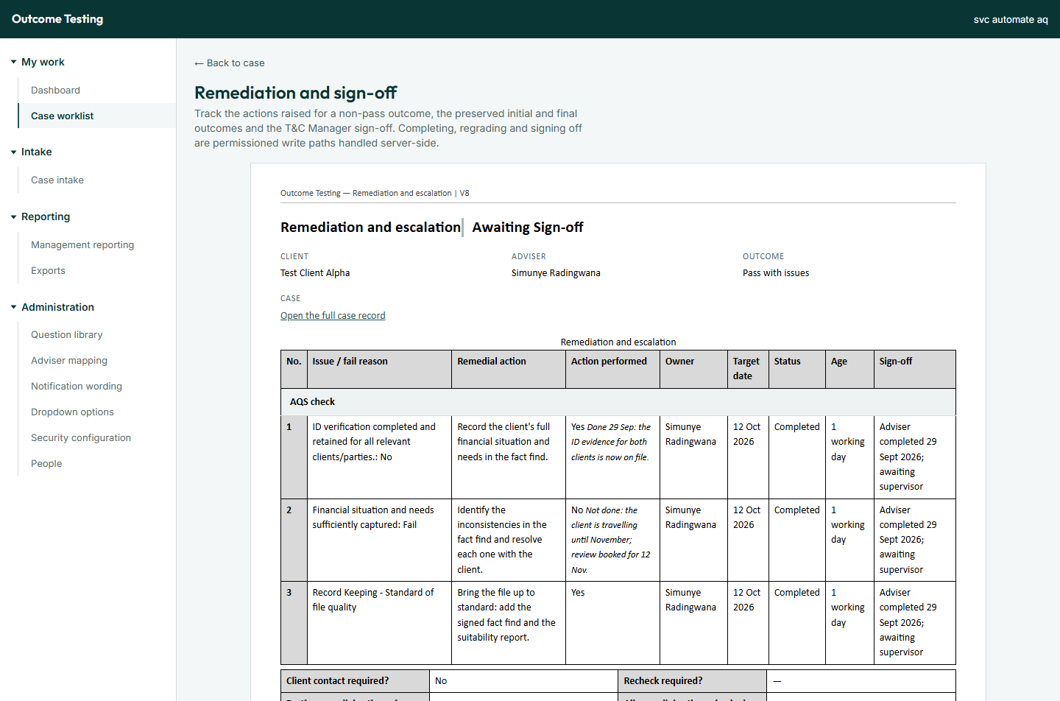
Figure 5. The remediation view of a case
This page is for viewing only. Advisers complete remediation and T&C Managers sign it off in the portal.

5.6 Viewing a Tax or AQS check
Click a check under Checks on this case to see the full completed checklist, laid out like the paper form. Click Save as PDF to print or save it. You cannot answer, grade or submit a check here; checkers do that in the portal.

5.7 The History tab
The History tab is the case's permanent audit trail: When, Action, By, Applied to (case, check, remediation action, outcome or sign-off), Reason and Details. Entries cannot be edited or removed.

5.8 Correcting a final outcome
Correcting (regrading) an outcome is a T&C Manager action, done in the portal after sign-off. It needs a reason, which is kept permanently, and the original grade is always kept beside the new one. Administrators do not regrade by default.

6. Case intake
Case intake brings new cases in from the Intelligent Office task extract, and shows the rows that failed so you can deal with them.
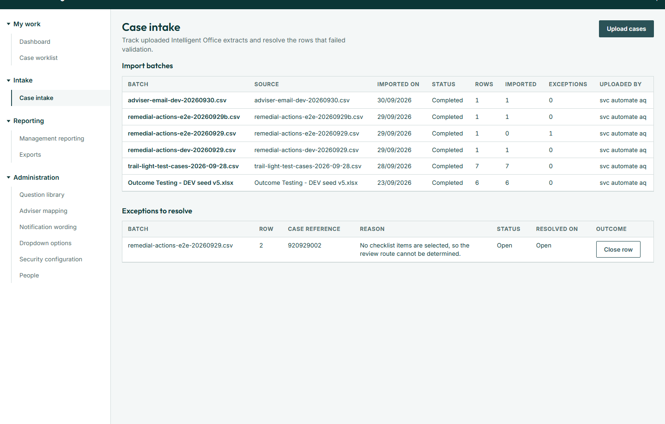
Figure 6. Case intake

How to upload an extract
- Export the task extract from Intelligent Office as .xlsx or .csv. It must have a TaskID column.
- Click Upload cases and choose the file. The import starts straight away; there is no preview step.
- Wait while it shows Reading file… and then Importing N rows….
- Read the result, for example Batch [ref]: 38 of 40 cases imported, 1 already existed, 1 failed.
- Click View imported cases to see them, or Download validation report for a row-by-row file of what happened.
Due dates Every new case is due three days after upload. The extract's own DueDate column is ignored.
If the whole file is refused, a red box explains why, for example The file is missing the "TaskID" column. or The file is not a valid .xlsx workbook. Fix the file and upload it again.

Why a row fails
- The TaskID is missing, or appears twice in the file.
- The case already exists. These rows are skipped and closed automatically.
- A date or dropdown value is not valid.
- The checklist items are missing or not recognised, so OTIS cannot work out which checks the case needs.

The two tables
Import batches lists every upload, newest first, with its row, imported and exception counts. Exceptions to resolve lists each failed row with its reason and status (Open, Resolved or Ignored).

How to close an exception
- In Exceptions to resolve, click Close row on an open row.
- Choose Resolved (the row was corrected and re-imported, or the case exists another way) or Ignored (the row was never a case).
- Enter a Note saying what was done. It is required and kept permanently.
- Click Close exception.
To import a corrected row, fix it in the extract and upload the file again. Cases already imported are skipped, so nothing is duplicated.

7. Management reporting
Management reporting shows live figures on outcomes, remediation and sign-off. It uses the same filter bar as the Dashboard.
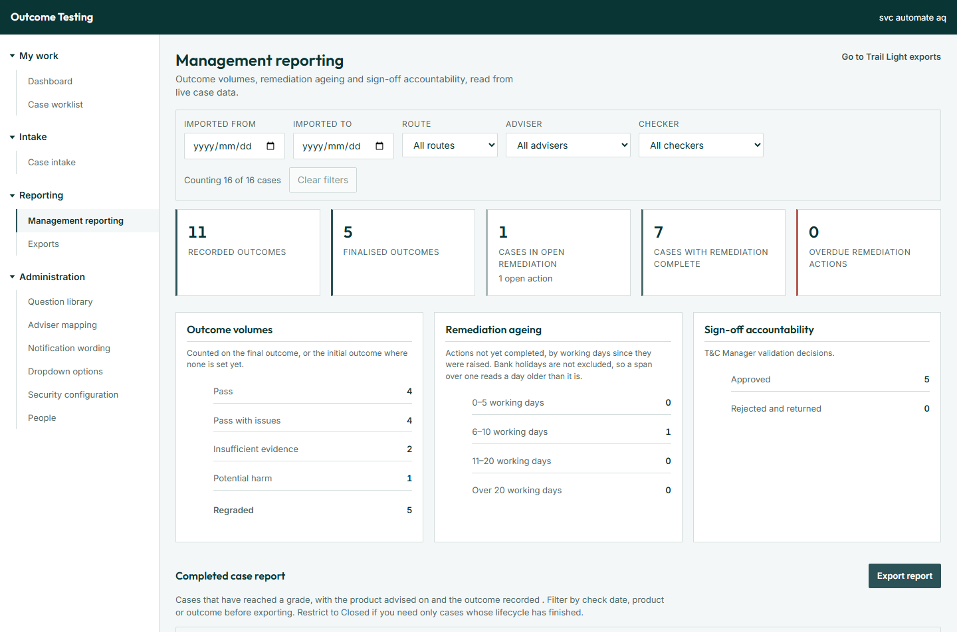
Figure 7. Management reporting
- Totals: recorded and finalised outcomes, cases in open remediation, cases with remediation complete, and overdue remediation actions.
- Outcome volumes: cases per grade, plus how many were regraded. The final grade is used where there is one.
- Remediation ageing: open actions in bands of 0–5, 6–10, 11–20 and over 20 working days.
- Sign-off accountability: how many sign-offs were approved, and how many rejected and returned.

Completed case report
The Completed case report lists every graded case. Filter it by Outcome, Product / solution type, Checked from / to, or tick Closed cases only.
- Set the filters.
- Click Export report and choose Excel or CSV.
Figures are calculated live each time; there is no saved report history. Go to Trail Light exports takes you to the Exports page.

8. Exports
Exports produces the Trail Light file of closed cases, on demand. Each export is a batch: a snapshot of the closed cases at the moment it was generated.
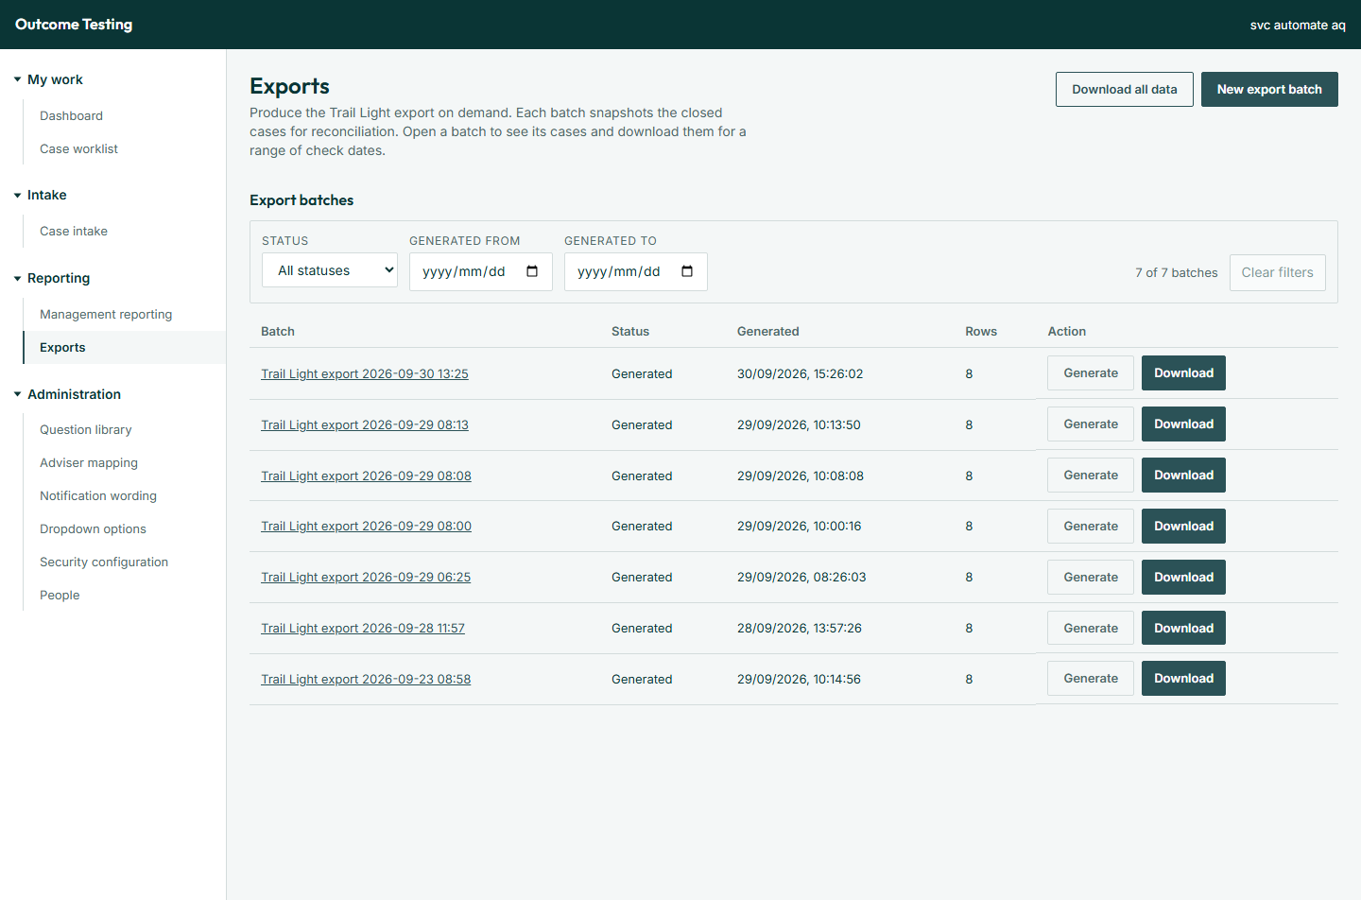
Figure 8. Exports

How to produce the Trail Light file
- Click New export batch. A draft batch named Trail Light export [date and time] appears.
- Click Generate on that batch. OTIS snapshots every case at status Closed, and confirms Generated N export record(s).
- To download every case in the batch, click Download and choose Excel or CSV.
- To include only some check dates, click the batch name, set Checked from and Checked to, then click Download Trail Light file.
- Check the file before sending it on.
The file is always named DFALIN1_outcometesting_YYYY_MM_DD and has 19 columns in a fixed order: adviser and paraplanner names and codes, case type, product, check date, client, pre or post check, the File Quality and Advice Quality grades, and who carries each fail.
- A batch can be generated only once. To produce a fresh file, create a new batch.
- If no cases are Closed, the batch has 0 rows and there is nothing to download.
- A closed case with no recorded outcome stops generation. Record the outcome, or reopen the case if it was closed by mistake.
- Adviser and paraplanner codes come from each person's Employee code on the People page.

Download all data
Download all data produces one Excel workbook with a sheet per type of record: cases, checks, answers, outcomes, remediation, sign-offs, imports, exports, the audit trail, the checklist, people, roles and permissions. Each sheet holds up to 5,000 rows; the message names any sheet left out or shortened.

9. Question library
The Question library is the checklist exactly as checkers answer it today, grouped into sections. Each section is owned by the Tax team, the AQS team, or Both.
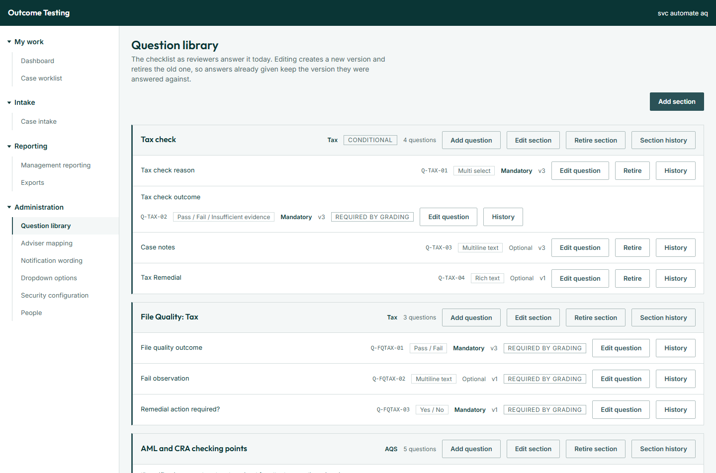
Figure 9. The Question library
Nothing is ever deleted Changing a question creates a new version and retires the old one. Retiring stops a question or section being asked from a date. Checks already submitted keep the exact questions and answers they had. Every change needs a start date of today or later.

Reading the library
- Each section shows its team, any Optional or Conditional flag, and how many questions it holds.
- Each question shows its wording, code, answer type, Mandatory or Optional, and its version number.
- Retired questions and sections are grouped at the bottom.
- History shows every change to a question, with who made it, when, why, and what changed. Section history does the same for a section.

How to add a section
- Click Add section.
- Enter a Section code (unique, never reused), a Name, optional Help text, the Team (Tax, AQS or Both) and a Display order.
- Tick Optional if its questions should not be required before a check is submitted.
- Optionally add questions straight away under Questions with Add a question (code, wording, answer type, mandatory).
- Click Add section.

How to edit a section
- Click Edit section.
- Change the Name, Help text, Team, Display order or Optional setting.
- Enter a Reason (required).
- Click Save changes.
Moving a section to a different team also changes which team sees it on checks already submitted (no answers are lost); choosing Both adds a team without removing one. Making a section optional takes effect immediately on every check not yet submitted.

How to retire a section
- Click Retire section.
- Set Stops being asked from (today or later) and enter a Reason.
- Click Retire section. The section and its questions leave the form from that date.

How to add a question
- Click Add question on the section.
- Enter the Wording, choose the Response type, tick Mandatory if it must be answered, and set Display order and Asked from.
- Enter a Question code (unique, never reused).
- Click Add question. A mandatory question becomes required on every check of that team not yet submitted on that day.
Answer types offered: Text, Multiline text, Rich text, Date, Single select, Multi select, Pass / Fail, Pass / Fail / Insufficient evidence, Pass / Fail / Insufficient evidence / N/A, Yes / No, Yes / No / N/A, Yes / No / Insufficient evidence, Grade, and Multi select (root causes).

How to change a question
- Click Edit question.
- Change the Wording, Response type, Mandatory or Display order, and set New wording asked from.
- Click Save new version. Checks already submitted keep the version they answered.

How to move a question to another section
- Click Edit question and choose a different Section. The other fields lock: change wording first, then move, or the other way round.
- Enter a New question code, a Reason, and the date it is Asked in the new section from.
- Click Move question.

How to retire a question
- Click Retire on the question.
- Set Stops being asked from and enter a Reason.
- Click Retire question.

Questions that cannot be retired
Nine questions are marked Required by grading. OTIS uses their answers to set outcomes, raise remediation and fill the Trail Light file, so they cannot be retired or moved. You can still change their wording.
Code | Why OTIS needs it
Q-GR-01 | The advice quality grade, which sets the case outcome
Q-GR-02 | The root cause, needed for every grade except Pass
Q-TAX-02 | The Tax check outcome, which decides whether remediation is needed
Q-FQ-01, Q-FQTAX-01 | The AQS and Tax file quality outcomes, used in the Trail Light file
Q-FQ-02, Q-FQTAX-02 | The AQS and Tax checker observations, carried into remediation
Q-FQ-03, Q-FQTAX-03 | "Remedial action required?" for AQS and Tax, which raises remediation

Fail reasons are not maintained on this page.

10. Adviser mapping
Adviser mapping links each adviser to their T&C Manager. Keep it current whenever advisers or managers join, move or leave.
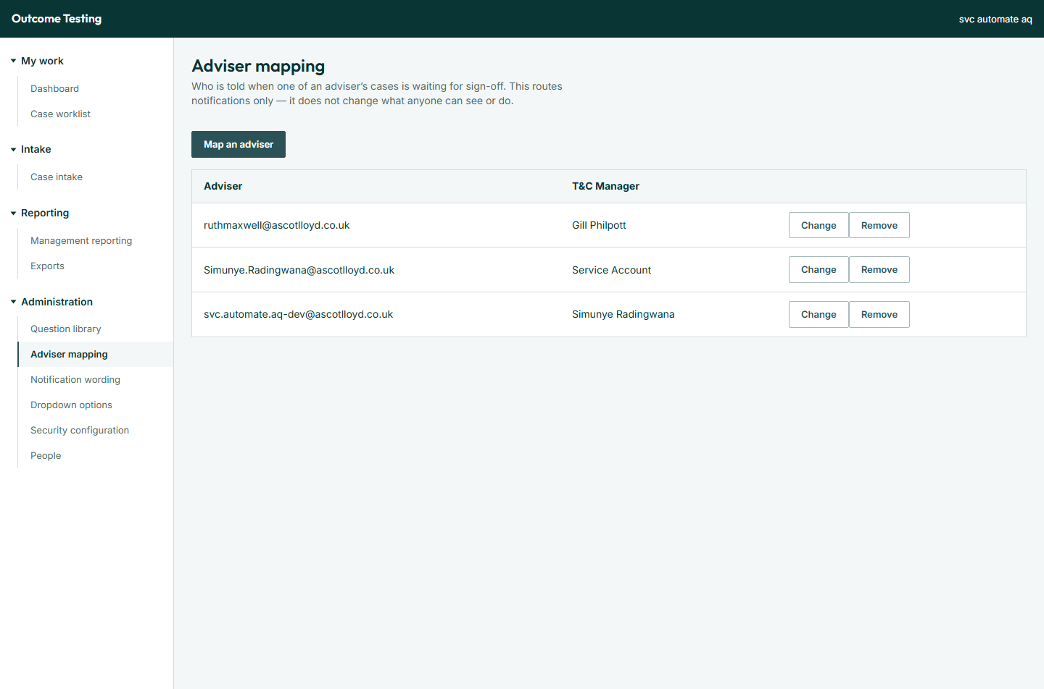
Figure 10. Adviser mapping
Why it matters The mapped T&C Manager is the person emailed when a case is waiting for sign-off. In the portal, only the mapped T&C Manager can sign off an adviser's remediation or record the final outcome; without a mapping, both are refused. (The note at the top of this page in the app still describes the mapping as affecting emails only.)

How to map an adviser
- Click Map an adviser.
- Choose the Adviser. Their email must match the adviser email on their cases, which comes from the Intelligent Office extract. If they are not listed, add them on the People page first.
- Choose the T&C Manager.
- Click Save.
Each adviser can be mapped once. To point an adviser at a different manager, click Change on their row, choose the new T&C Manager and click Save. To remove a mapping, click Remove, then Remove mapping. Mappings are added one at a time.

11. Dropdown options
Dropdown options controls the choices offered in the case details dropdowns. Changes take effect immediately.
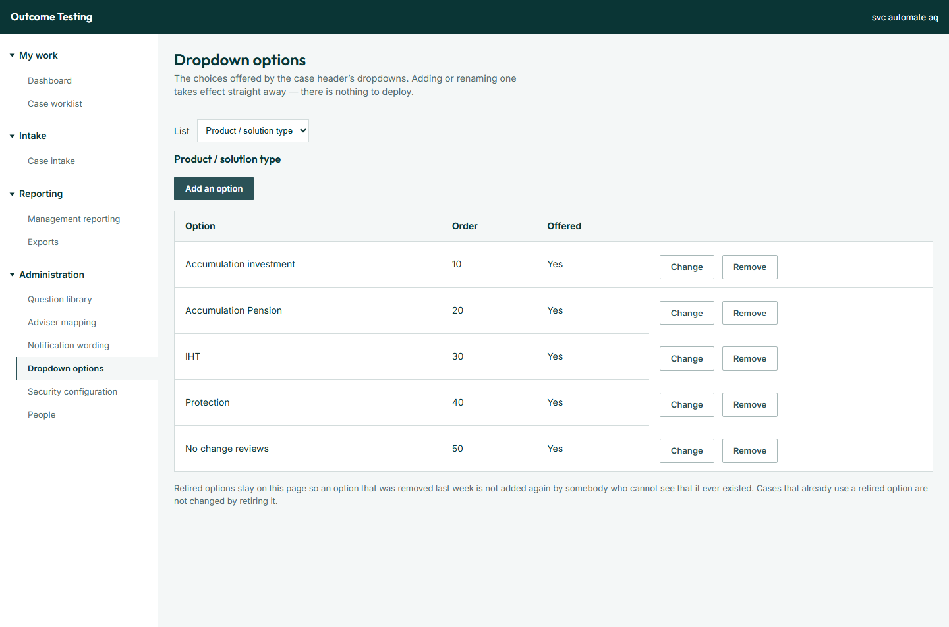
Figure 11. Dropdown options
Choose the list to work on in List: Product / solution type, Sample source, Case type, Pre or post check, Products (a case can have several) or Vulnerable client. The table shows each Option, its Order, and whether it is Offered or Retired on [date].

How to add or rename an option
- Click Add an option, or Change on an existing one.
- Enter the Option name. Renaming an option renames it on every case that already uses it.
- Optionally set Sort order (blank puts it at the end), Offered from and Offered until. An end date retires the option on that day.
- Click Save.

How to remove an option
- Click Remove on the option.
- Choose Retire to stop offering it on new cases. Cases that already use it are unaffected, and you can bring it back later.
- Or choose Delete permanently, only if it was added by mistake. OTIS refuses to delete an option any case has used.
To offer a retired option again, click Reinstate. Retired options stay listed so they are not added twice by mistake.

12. Notification wording
Notification wording controls the subject, body and recipient of every email OTIS sends. A letter you have not edited uses the built-in wording, shown as Built-in. Your changes apply from the next email sent.
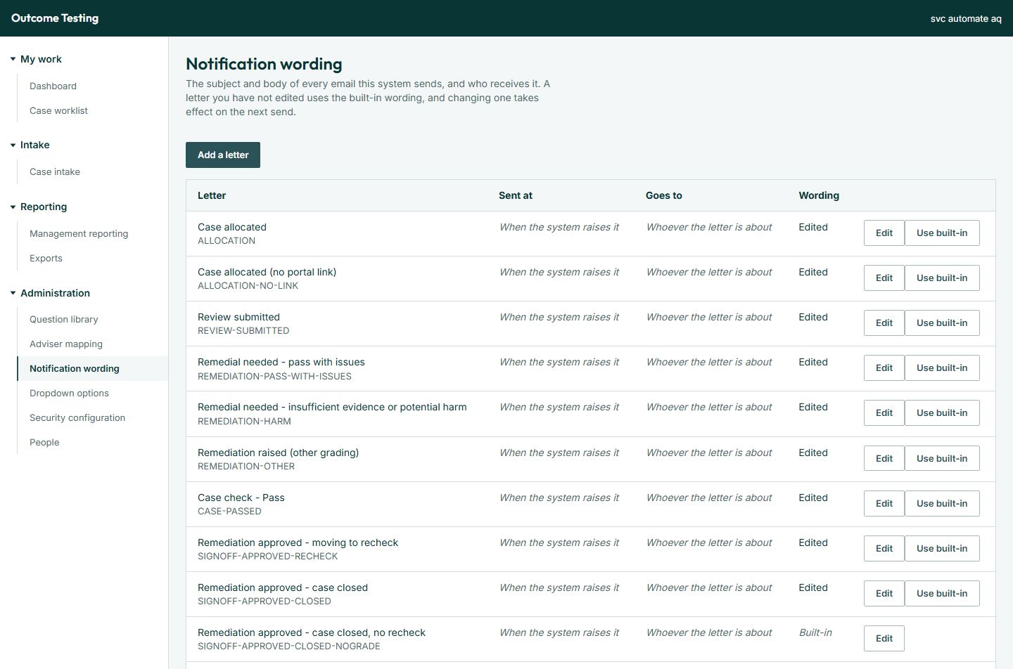
Figure 12. Notification wording

The emails OTIS sends
Letter | When it is sent | Who receives it
Case allocated | A check is allocated to a checker (a version without a link is used if the portal address is not set) | The checker
Review submitted | A checker submits a check; the completed check is attached as a PDF | The paraplanner on the case
Remedial needed - pass with issues | Remediation is raised on a Pass with issues grade | The adviser
Remedial needed - insufficient evidence or potential harm | Remediation is raised on either of those grades | The adviser
Remediation raised (other grading) | Remediation is raised on any other grading | The adviser
Case check - Pass | A case closes as a Pass with nothing to put right | The adviser
Remediation approved - moving to recheck | Sign-off approved; the case goes to recheck | The adviser
Remediation approved - case closed | Sign-off approved with a final grade | The adviser
Remediation approved - case closed, no recheck | Sign-off approved; no recheck needed | The adviser
Remediation sent back | Sign-off rejected; the adviser's 10 working days restart | The adviser
Final outcome owed | A case reaches Awaiting Recheck | The T&C Manager who signed off
Sign-off due | The adviser completes every remediation action | The adviser's mapped T&C Manager

How to edit a letter
- Click Edit on the letter. If it has never been edited, the built-in wording is filled in for you to change.
- Edit the Subject and Body. Use the toolbar for formatting and links; anything else is removed on save.
- To insert case information, click a placeholder button under Insert into. It goes into the field you last clicked in.
- Optionally change Goes to: Whoever the letter is about (recommended), Adviser, T&C Manager, Para-planner, Checker, or A named contact (the same person for every case).
- Click Save.
Save stays greyed out while a warning shows, for example when the subject or body is empty, or a placeholder is used that this letter cannot fill.

Placeholders
Placeholder | Becomes
{{reference}} | The case reference
{{adviser}}, {{client}} | The adviser's and client's names
{{caseLink}}, {{caseButton}} | A link, or a styled button, to the case in the portal
{{dueText}} | A sentence giving the due date
{{grading}}, {{finalOutcome}} | The grade that caused the letter, or the final outcome at sign-off
{{notes}} | The T&C Manager's notes, if any
{{completedCheck}} | Attaches the completed check as a PDF; adds no text

The placeholder buttons shown for each letter are the ones it can use.

How to add your own letter
- Click Add a letter. Your letter is sent in addition to the built-in ones; it does not replace any.
- Enter a Name. The code is created from it.
- Choose Sent at: Allocation, Review submitted, Remediation assigned, Sign-off approved, Sign-off rejected, Case passed, Recheck due or Sign-off due.
- Choose who it Goes to, and write the Subject and Body. Your own letters can use reference, adviser, client, caseLink, caseButton and completedCheck.
- Click Add the letter.

Undoing changes
- Use built-in puts an edited letter back to its original wording and recipient. Your version cannot be recovered.
- Remove deletes a letter you added. It stops being sent immediately.
There is no preview. To check a change, trigger the email on a test case in a test environment.

13. People
People lists everyone known to OTIS, keyed on their work email, with their roles and employee codes. Anyone named on a case but missing from the directory is also listed, marked Not in directory; they cannot be given work until added. The busiest people are listed first.
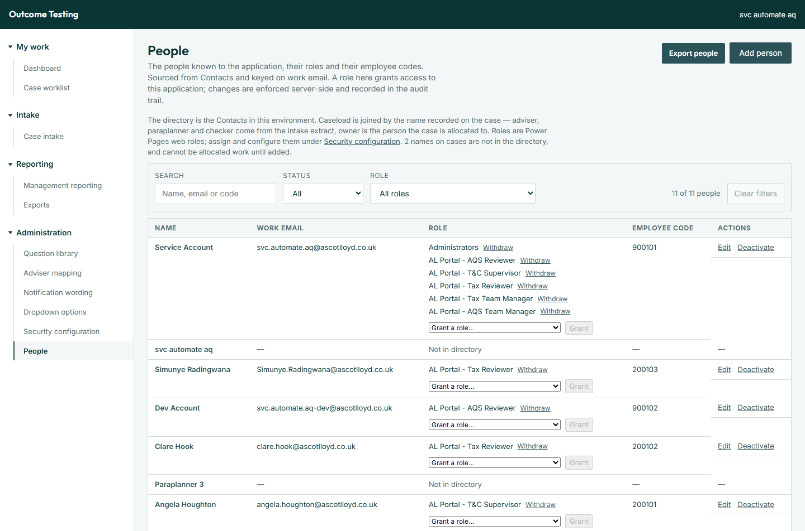
Figure 13. People
Filter with Search (name, email or code), Status (All, Active, Inactive) and Role. Click Export people for an Excel or CSV file of the people listed, with their case counts.

How to add a person
- Click Add person.
- Enter their Full name and Work email.
- Click Add person. The message [Name] added to the people directory. confirms it.
- Grant them a role (below). Without one they cannot use OTIS.
If the email belongs to a deactivated person, OTIS asks you to reactivate them instead.

How to edit a person
- Click Edit on their row.
- Change the Full name or Employee code. The employee code fills their code in the Trail Light file. The work email cannot be changed.
- Click Save changes.

How to deactivate or reactivate a person
Click Deactivate on their row. It takes effect immediately, with no confirmation. They lose access straight away and cannot be given work. Their roles are kept, so Reactivate restores them exactly as they were.

How to grant or withdraw a role
- In the person's Role cell, choose a role from Grant a role….
- Click Grant. The message [Role] granted to [email]. confirms it.
- To take a role away, click Withdraw beside it. This is immediate.
One person can hold several roles. Some roles are listed but can only be changed in Security configuration.

The roles
Role | Who it is for | Where they work
AL Portal - AQS Reviewer | AQS checkers: pick up and complete AQS checks | Portal
AL Portal - Tax Reviewer | Tax checkers: complete Tax checks allocated to them | Portal
AL Portal - Adviser Remediation | Advisers: put right what checks found on their cases | Portal
AL Portal - Planner | Paraplanners: receive emails only | Email
AL Portal - T&C Supervisor | T&C Managers: sign off remediation and record final outcomes | Portal
AL Portal - AQS Team Manager, AL Portal - Tax Team Manager | Allocate their own team's checks and watch workload | App
AL Portal - OTIS Manager | Run the process: intake, allocation, reports, exports, mappings, wording and lists | App
AL Portal - Portal Administrator, Administrators | Full administration | App and portal

A person's cases
Click a person's name to see every case where they are the adviser, paraplanner, checker or owner, with totals and outcomes. Click Export these cases for a file, or Open in the case worklist with all filters to work with them there.

14. Security configuration
Security configuration controls who holds which role and what each role can see and do. Every change is recorded in the audit trail.
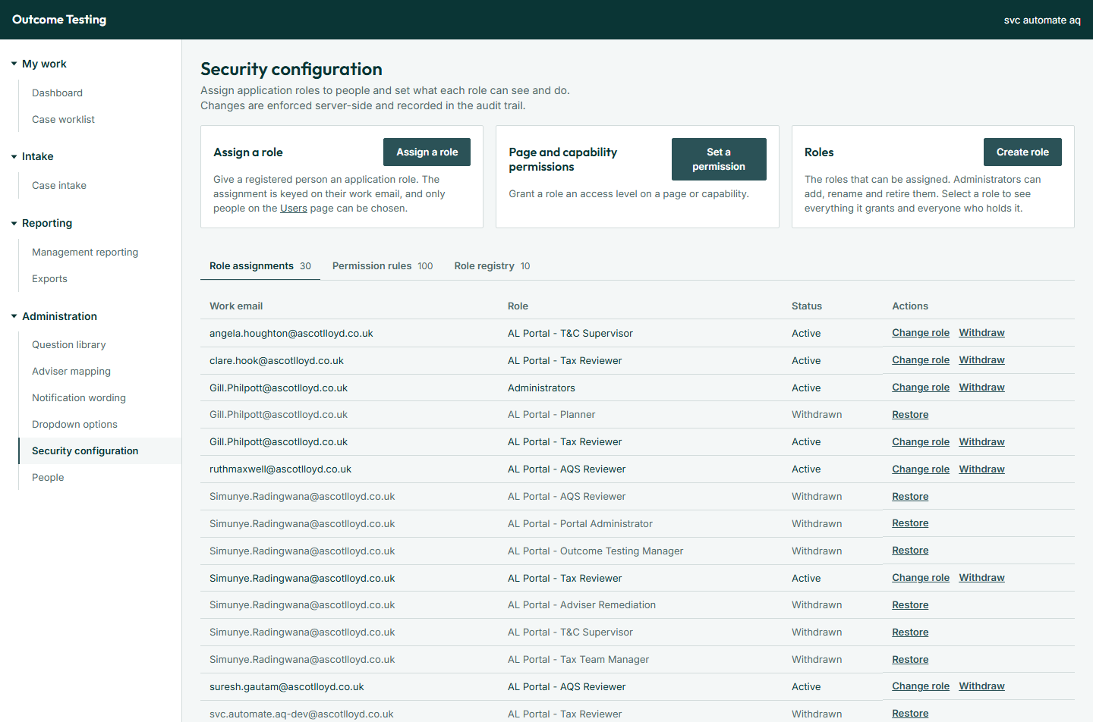
Figure 14. Security configuration
Important Once any permission rule has been saved, only saved rules give access. A role with no rule for a page has no access to it. Withdrawing a rule removes the access; it does not fall back to a default.

How to assign a role
- Click Assign a role.
- Choose the Person (active people only) and the Role.
- Click Assign role.

How to set what a role can do
- Click Set a permission.
- Choose the Role, the Resource (a page or an action), and the Access level: None, View, Edit or Manage.
- Click Set permission. This replaces any existing rule for that role and resource.

How to create a role
- Click Create role.
- Enter a Role name and a Description. The name cannot be changed later; to rename a role, create a new one and move people across.
- Click Create role, then give it permissions and assign it to people.

The three tabs
Tab | What you can do
Role assignments | See who holds which role. Change role swaps a person's role; Withdraw and Restore take effect immediately.
Permission rules | See every rule. Change level edits it; Withdraw removes the access; Restore brings it back.
Role registry | See every role. Edit changes its description; Retire withdraws all its assignments and rules; Restore brings the role back (re-assign it afterwards).

A role's own page
Click a role's name to see What this role grants (each resource and level, marked Default or Set by administrator) and Who holds this role. If a role was granted outside OTIS, the holder's status says so: click Adopt to record it in OTIS, or Revoke to remove it everywhere.

Resources
The screen shows each resource by its short name. What each one controls:
Resource | Controls
page.dashboard | The Dashboard
page.cases | The case worklist and case pages; Edit allows editing case details and recording who carries a fail
page.reviews | Viewing Tax and AQS checks
page.remediation | Viewing remediation
page.imports | Case intake; Edit allows uploading and closing exceptions
page.reports | Management reporting
page.exports | The Exports page
page.admin.questions | The Question library page
page.admin.advisers | Adviser mapping; Manage allows changes
page.admin.templates | Notification wording; Manage allows changes
page.admin.lists | Dropdown options; Manage allows changes
page.admin.security | Security configuration
page.admin.users | People
command.assign | Allocating Tax and AQS checks
case.duedate | Changing a case's due date
command.regrade | Correcting a final outcome
command.signoff | Signing off remediation
remediation.complete | Completing remediation actions
question.retire | Changing the question library (Edit)
export.generate | Creating and generating export batches
permission.manage | Managing people, roles and permissions (Manage)

15. Regular tasks
How often | Task | Where
Daily | Upload the Intelligent Office extract and close any exceptions | Case intake
Daily | Allocate queued Tax checks, and AQS checks not picked up | Case worklist → Edit case details
Daily | Look for cases waiting too long, cases awaiting a route, and overdue remediation | Dashboard
When people join, move or leave | Add, edit or deactivate them, and grant or withdraw roles | People
When advisers or managers change | Keep every adviser mapped to their T&C Manager | Adviser mapping
When the checklist changes | Add, change or retire questions and sections, with a start date | Question library
When asked | Produce the Trail Light file and check it before sending | Exports
As needed | Correct case details, run reports, adjust email wording and dropdown lists | Various

16. Good practice
- Grant only the roles a person needs for their job. A role decides what they can see.
- Give a reason when you change a case, even where it is optional. It is kept in the case history.
- Test access changes with an ordinary account, not an administrator account, which sees everything.
- Retire rather than delete. Retired questions, options and roles keep past records reading correctly.
- Check the Trail Light file before it is sent on.

17. Troubleshooting
What you see | What it means | What to do
… has been deactivated, so work cannot be allocated to them. | The person is deactivated | Reactivate them on People, then allocate again
… has no OTIS security role … | Their account lacks the OTIS security role | Ask the system owner to add the OTIS role and Basic User to their account
No portal contact has the work email … | They are not in the directory | Add them on People, then allocate again
This check was allocated by someone else while you were working. | Another person changed it first | Reload the page and try again
This case changed since you loaded it. | The case was edited by someone else | Reload the page and try again
A case cannot move from X to Y. | That status change is not allowed | Choose one of the statuses the message lists
A T&C Manager cannot sign off or record a final outcome | The adviser has no mapping, or is mapped to someone else | Map the adviser to the right T&C Manager
An adviser cannot see their case | The adviser on the case does not match a person | Correct the adviser on the case, or the person's name on People
Someone cannot open the portal at all | They are not on the portal's site access list | Ask the system owner to add them (or their group) to site access
Someone signs in but sees nothing | They have no role | Grant a role on People
An email has not arrived | Emails are queued and then sent by the mail system | Check the recipient's email address on People; if it is right, contact the system owner
You do not have permission to perform this action. | Your role lacks that permission | Ask another administrator to check Security configuration

For anything else, contact the OTIS system owner with the case reference or page name and a short description of what you were trying to do.

